**1. bankerAlgorithm**

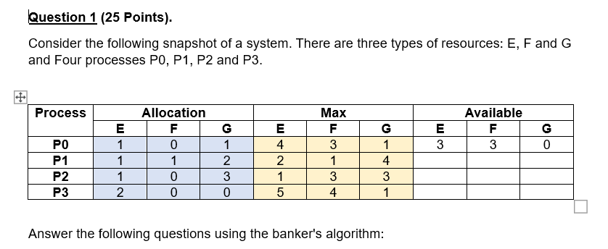

**2. diskSchedulingAlgorithm**

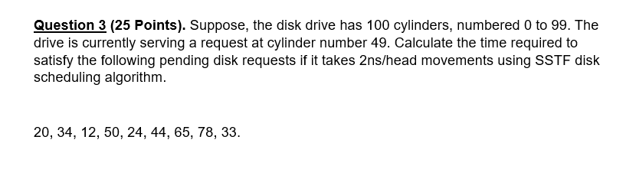

**3. pageFault**

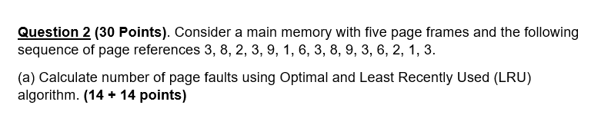

**4. PriorityScheduling**

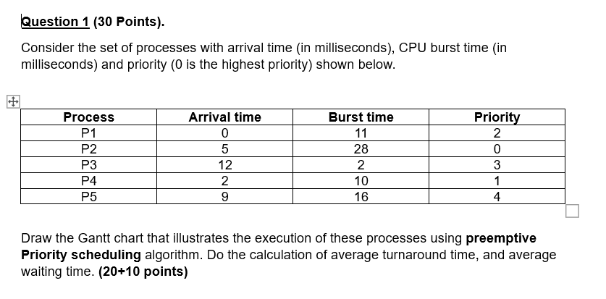

**5. PhysicalAddress**

